**PROJECT 9**

**Writing Investigation & Research Report**

***By Titobiloluwa (Tito) Ilori***

**Table of Content**

|  | **The Stuxnet Virus Attack** | **Page No.** | |
| --- | --- | --- | --- |
| **1.1** | **Who Conducted the Attack** | | **2** |
| **1.2** | **Attack Victims** | | **2** |
| **1.3** | **Attack Technologies and Tools Used** | | **3** |
| **1.4** | **When Was the Attack Discovered** | | **4** |
| **1.5** | **The Motivation of the Attack** | | **4** |
| **1.6** | **The Outcome or Impact of the Attack** | | **4** |
| **1.7** | **Security Controls to Mitigate the Attack in The Future** | | **5** |
| **2** | **Conclusion** | | **5** |
|  | **Appendix A: References** | | **6** |

**The Stuxnet Virus Attack**

**1.1 Who Conducted the Attack**

The sophisticated Stuxnet attack was orchestrated through a collaboration between the U.S. National Security Agency (NSA), the Central Intelligence Agency (CIA), and Israeli intelligence agencies. The classified program to develop the worm was given the code name "Operation Olympic Games"; it was begun under President George W. Bush and continued under President Obama. 1,2,3

**1.2 Attack Victims:**

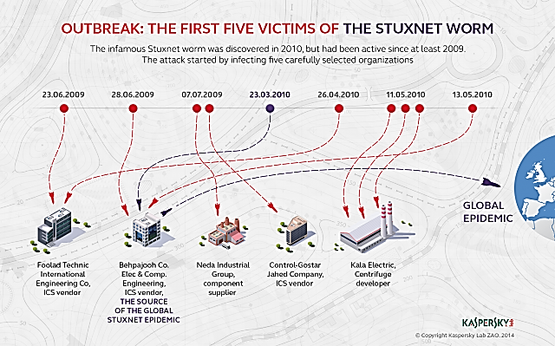

*Fig. 1: First Five Victims of The Stuxnet Worm 4*

A recent analysis sheds light on Stuxnet's enigmatic strategy. Initial targets within Iran's Industrial Control Systems (ICS) sector included organizations in ICS development and material supply. Notably, the fifth victim was a manufacturer of industrial products, including uranium enrichment centrifuges—Stuxnet's likely focus.4

The attackers exploited data exchange between these organizations and clients, such as uranium enrichment facilities, to spread the malware. This approach appears successful, highlighting a calculated supply-chain attack strategy.4

According to Alexander Gostev of Kaspersky Lab, this reveals a well-planned operation: "This is an example of a supply-chain attack vector, where the malware is delivered to the target organization indirectly via networks of partners that the target organization may work with."4 While its primary target was Iran, the attack later expanded to affect various industrial and energy-producing sites, such as water treatment plants, power plants, and gas lines.2

**1.3 Attack Technologies and Tools Used**

Stuxnet's adaptable design could be used as a platform to target various sectors, including modern Supervisory Control and Data Acquisition (SCADA) systems and Programmable Logic Controllers (PLCs) in industries like assembly lines and power plants. The malware comprises three key modules: a worm responsible for the main attack actions, a link file that spreads replicated copies of the worm, and a rootkit component that conceals malicious files and processes to evade detection. This modular architecture allowed Stuxnet to effectively target SCADA and PLC systems while maintaining covert operations.5

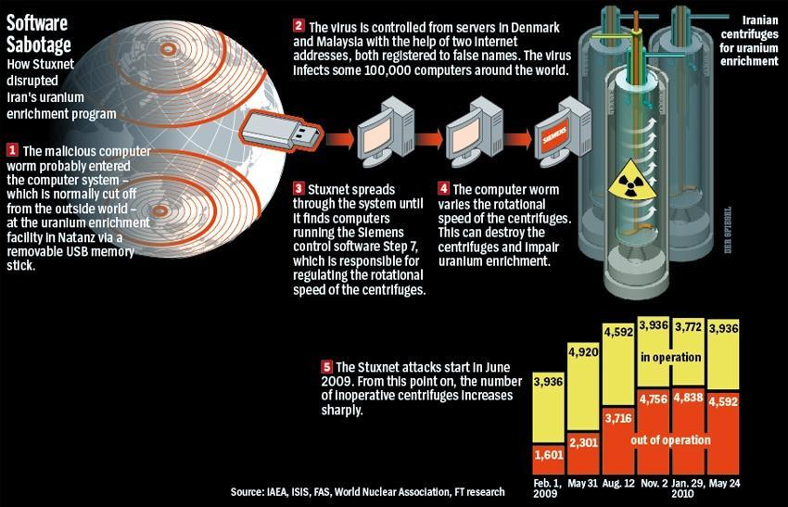

*Fig. 2: Stuxnet Attack Mechanism.5*

Stuxnet exhibited unparalleled sophistication, capitalizing on multiple undisclosed Windows zero-day vulnerabilities to infiltrate and propagate. The attack centered on programmable logic controllers (PLCs) utilized in industrial automation and harnessed Siemens Step 7 software. The worm propagated through Microsoft Windows computers, primarily leveraging USB sticks as a transmission medium.2

**1.4 When Was the Attack Discovered**

The Stuxnet attack came to light in the year 2010.1,2

**1.5 The Motivation of the Attack**

The collaborative efforts of the U.S. and Israeli governments in crafting and deploying Stuxnet were driven by the ambition to disrupt or delay Iran's nuclear weapons program. The strategy was to hinder Iran's uranium enrichment process, potentially obstructing the development of atomic weapons. The attack aimed to avert the possibility of Israel resorting to airstrikes on Iranian nuclear facilities, a move that could have escalated into a broader regional conflict.1, 2.

**1.6 The Outcome or Impact of the Attack**

Stuxnet demonstrated its efficacy by successfully targeting Iran's Natanz uranium enrichment facility.

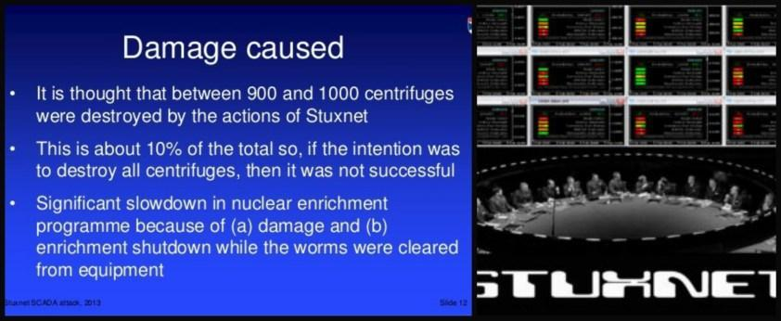

*Fig. 3: Highlight of System Damage Caused by Stuxnet.5*

The Federation of American Scientists (FAS) reported a notable drop in Iran's operational enrichment centrifuges, declining from around 4,700 to about 3,900 during the period aligned with the nuclear incident referred to by WikiLeaks. The Institute for Science and International Security (ISIS) proposes that Stuxnet could plausibly account for this decline, potentially causing the destruction of up to 1,000 centrifuges (10 percent) between November 2009 and late January 2010.5

The worm's impact was tangible, causing disruptions in the operation of centrifuges responsible for uranium enrichment. This marked a watershed moment, underscoring the potential of cyberattacks to yield tangible real-world consequences.1 Over time, Stuxnet's adaptations were employed to target additional facilities beyond Iran, revealing its broader utility.2

**1.7 Security Controls to Mitigate the Attack in The Future**

Patching and Updates6: Regularly applying security patches and updates to operating systems and software is paramount to mitigating vulnerabilities exploited by malware like Stuxnet.

Network Segmentation7: To forestall malware propagation, critical industrial networks should be segregated from the public internet.

Robust Access Controls7: Enforce stringent access controls through firewalls and intrusion detection systems to monitor and manage network traffic effectively.

USB Device Policies6: Instate and enforce policies governing the use of USB drives and other removable media. Disabling autorun functionality curbs the automatic execution of malicious code from USB devices.

Comprehensive Security Audits7: Regular security audits identify vulnerabilities and potential malware entry points, facilitating timely counteraction.

Behavioural Analysis Tools: Employ behavioural analysis tools to detect aberrant activity patterns within industrial control systems, indicative of malware infection.

Cybersecurity Training7: Disseminate cybersecurity training to employees, heightening vigilance against social engineering and unauthorized device use.

Collaboration with Vendors7: Forge strong collaborations with software and hardware vendors to ensure timely provisions of updates and patches for critical systems.

Air-Gapping Critical Systems: If feasible, physically segregate crucial systems from external networks, mitigating the risk of external threat infiltration.

**2 Conclusion**

The Stuxnet attack underscored the potential for cyberattacks to transcend virtual boundaries and impact critical industrial infrastructure. Consequently, organizations must adopt comprehensive cybersecurity strategies to safeguard their operations against the evolving threats posed by sophisticated malware such as Stuxnet.

**Appendix A: References**

1. The Stuxnet Worm | Paul Mueller and Babak Yadegari (2012) - <https://www2.cs.arizona.edu/~collberg/Teaching/466-566/2012/Resources/presentations/topic9-final/report.pdf>

2. STUXNET | Matisoft Cybersecurity Labs - <https://www.matisoftlabs.com/case-studies/stuxnet>

3. Contributors. Stuxnet. Technical report, World Wide Web, <http://en.wikipedia.org/wiki/Stuxnet>

4. Stuxnet Patient Zero: First Victims of the Infamous Worm Revealed | Kaspersky (November 11, 2014) - <https://www.kaspersky.com/about/press-releases/2014_stuxnet-patient-zero-first-victims-of-the-infamous-worm-revealed>

5. Remote Control: Stuxnet | Sara Kirchner (December 7, 2017) - <https://roughdiplomacy.com/stuxnet/>

6. Stuxnet Malware Mitigation (Update B) | CISA - ICS ADVISORY (January 08, 2014) - <https://www.cisa.gov/news-events/ics-advisories/icsa-10-238-01b#:~:text=ICS%2DCERT%20recommends%20that%20control,to%20making%20any%20system%20changes>.

7. Stuxnet Mitigation | SCADA Hacker (January 21, 2014) - <https://scadahacker.com/resources/stuxnet-mitigation.html>